Sodium channels

Nav1.1
Rhodes et al, 2004

Parameters | Experimental values | Reference | Simulation values
Temperature | not available |  | 22°C (preset value)
Sodium reversal potential | ~64 mV | Rhodes et al, 2004 (fig 3a) | 64 mV (preset value)
TC HMA of normalized conductance | -23.6 ± 1.2 mV | Rhodes et al, 2004 (Table 1) | -23.0 mV
Slope of normalized conductance | 7.4 ± 0.3 | Rhodes et al, 2004 (Table 1) | 7.7
SS HMI of normalised current of fast inactivation | -64.2 ± 1.1 mV | Rhodes et al, 2004 (Table 1) | -63.8 mV
Slope of normalized current of fast inactivation | -5.8 ± 0.1 | Rhodes et al, 2004 (Table 1) | -6.0
First time constant of the recovery from fast inactivation | 3.8 ± 0.5 ms | Rhodes et al, 2004 (Table 1) | 3.9 ms
Fraction of first recovery from fast inactivation | 83 ± 2 % | Rhodes et al, 2004 (Table 1) | 81 %
Second time constant of the recovery from fast inactivation | 96 ± 16 ms | Rhodes et al, 2004 (Table 1) | 102 ms
Fraction of second recovery from fast inactivation | 17 ± 2 % | Rhodes et al, 2004 (Table 1) | 18 %

TC: transient current; SS: steady-state; HMA: half maximal activation; HMI: half maximal inactivation

Voltage-clamp: -80 mV to 40 mV in step of 10 mV
see Rhodes et al, 2004, fig 1a

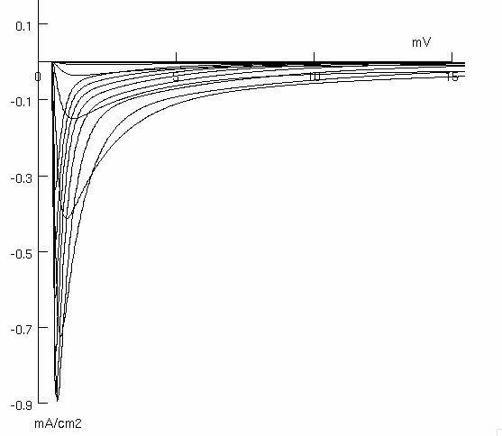

Voltage-current relationship
see Rhodes et al, 2004, fig 3a

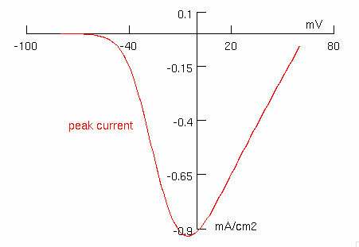

Voltage dependence of the normalised conductance
see Rhodes et al, 2004, fig 3b

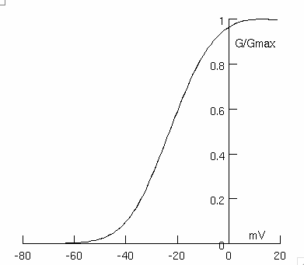

Voltage dependence of normalized current during fast inactivation
see Rhodes et al, 2004, fig 3c

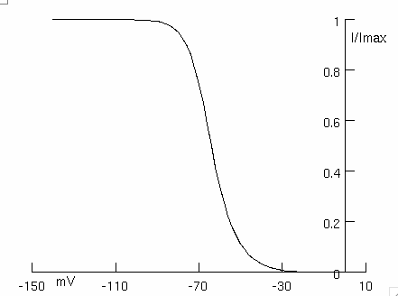

Recovery from fast inactivation
see Rhodes et al, 2004, fig 3d

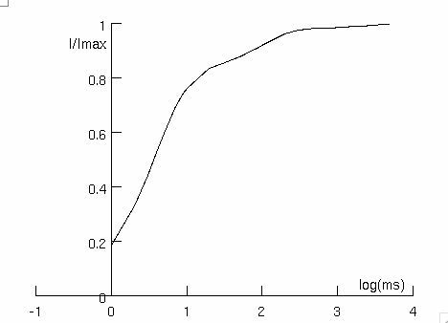

Nav1.2
Misra et al, 2008

Parameters | Experimental values | Reference | Simulation values
Temperature | 21-23°C | Misra et al, 2008 (pg 3) | 22°C
Sodium reversal potential | 65 mV ? | Misra et al, 2008 (fig 2A) | 65 mV
TC HMA (normalized conductance) | -25.3 ± 1.4 mV | Misra et al, 2008 (table 1) | -25.6 mV
TC Slope (normalized conductance) | 7.5 ± 0.4 | Misra et al, 2008 (table 1) | 7.4
TC HMI for fast inactivation (normalized current) | -67.4 ± 1.7 mV | Misra et al, 2008 (table 1) | -67.5 mV
TC Slope for fast inactivation (normalized current) | 9.1 ± 0.8 | Misra et al, 2008 (table 1) | -8.9
First time constant of the recovery from inactivation | 1.4 ± 0.1 ms | Misra et al, 2008 (table 1) | 1.5 ms
Fractional recovery with first time constant | 75 ± 2 % | Misra et al, 2008 (table 1) | 76 %
Second time constant of the recovery from inactivation | 53.6 ± 6.9 ms | Misra et al, 2008 (table 1) | 53.6 ms
Fractional recovery with second time constant | 24 ± 2 % | Misra et al, 2008 (table 1) | 24 %

TC: transient current; HMA: half maximal activation; HMI: half maximal inactivation

Voltage-clamp: -120 mV to 60 mV in step of 10 mV
see Misra et al, 2008, fig 1B

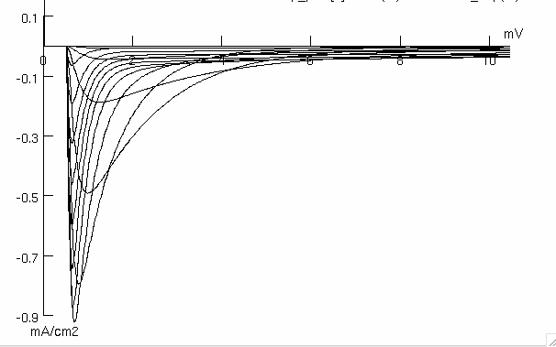

Voltage-current relationship
see Misra et al, 2008, fig 2A

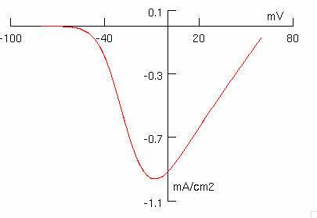

Voltage dependence of the normalised conductance
see Misra et al, 2008, fig 2B

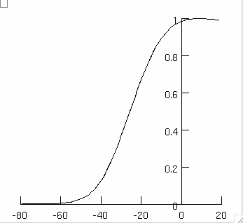

Voltage dependence of normalized current during fast inactivation
see Misra et al, 2008, fig 2C
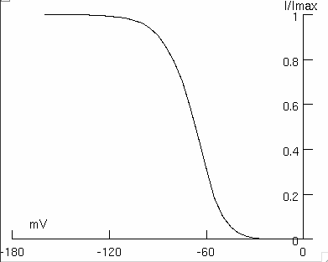

Recovery from fast inactivation
see Misra et al, 2008, fig 3d

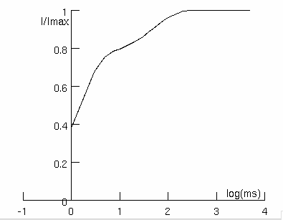

Nav1.3
Clare et al, 2000; Cusdin et al, 2010

Parameters | Experimental values | Reference | Simulation values  (nav13_p.mod)
Temperature | 19°C | Cusdin et al, 2010 (pg 33405) | 19°C (preset value)
Sodium reversal potential | not available |  | 64 mV (preset value)
TC HMA (normalized conductance) | -24.1 ± 0.9 mV | Cusdin et al, 2010 (table 2) | -24.0 mV
TC activation slope (normalized conductance) | 7.8 ± 0.1 | Cusdin et al, 2010 (table 2) | 7.4
SS HMI (normalised current) | -71.9 ± 1 mV | Cusdin et al, 2010 (table 3) | -72.3 mV
SS inactivation slope (normalised current) | 7.4 ± 0.3 | Cusdin et al, 2010 (table 3) | -7.7
Time constant of the recovery from inactivation | 13 ± 2 ms | Clare et al, 2000 (fig 2) | 13.5 ms

TC: transient current; HMA: half maximal activation; HMI: half maximal inactivation

Voltage-clamp: -90 mV to +30 mV in step of 10 mV
see Cusdin et al, 2010, fig 1A

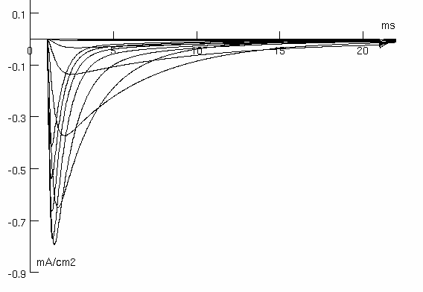

Voltage dependence of the normalised conductance
see Cusdin et al, 2010, fig 1B

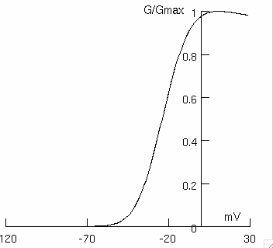

Voltage dependence of normalized current after steady-state fast inactivation
see Cusdin et al, 2010, fig 2B

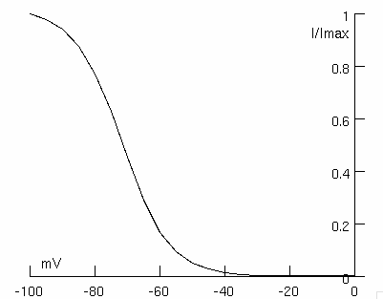

Nav1.4
Arnold et al, 2015

Parameters | Experimental values | Reference | Simulation values
Temperature | not available |  | 22°C (preset value)
Sodium reversal potential | not available |  | 64 mV (preset value)
TC HMA (normalized conductance) | -23.7 ± 1.2 mV | Arnold et al, 2015 (Table 1) | -23.5 mV
TC Slope (normalized conductance) | 7.7 ± 0.2 | Arnold et al, 2015 (Table 1) | 7.2
SS HMI for fast inactivation (normalised current) | -75.9 ± 1.6 mV | Arnold et al, 2015 (Table 1) | -76.0 mV
SS Slope for fast inactivation (normalized current) | 7.2 ± 0.4 | Arnold et al, 2015 (Table 1) | 6.9
First time constant of the recovery from fast inactivation | 2.3 ± 0.2 ms | Arnold et al, 2015 (Table 1) | 2.5
Percentage of 'fast' recovery | 84 ± 4 % | Arnold et al, 2015 (Table 1) | 82
Second time constant of the recovery from fast inactivation | 113 ± 43 ms | Arnold et al, 2015 (Table 1) | 113
Percentage of 'slow' recovery | 16 ± 4 % | Arnold et al, 2015 (Table 1) | 18

TC: transient current; SS: steady-state; HMA: half maximal activation; HMI: half maximal inactivation

Voltage-current relationship
see Arnold et al, 2015, fig 4A

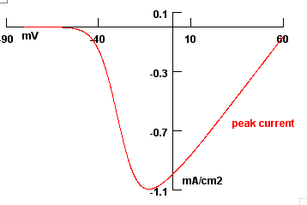

Voltage dependence of the normalised conductance
see Arnold et al, 2015, fig 4B

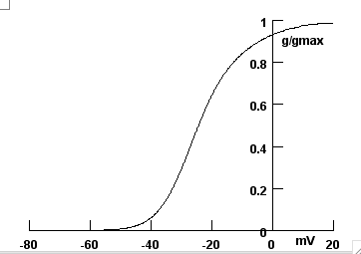

Steady-state availability during fast inactivation
see Arnold et al, 2015, fig 4C

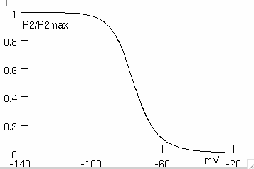

Recovery from fast inactivation
see Arnold et al, 2015, fig 4D

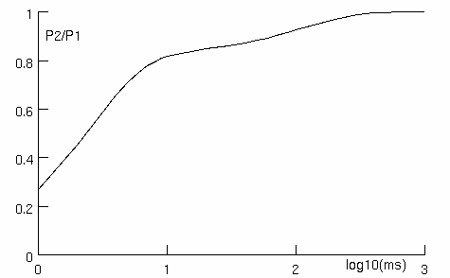

Nav1.5
Sheets and Hanck, 1999

Parameters | Experimental values | Reference | Simulation values
Temperature | 12°C | Sheets and Hanck, 1999 (pg 428) | 12°C
Sodium reversal potential | not available |  | 60 mV
TC HMA (normalized conductance) | -56 ± 5 mV | Sheets and Hanck, 1999 (fig 1) | -50.8 mV
TC Slope (normalized conductance) | -6.6 ± 0.7 | Sheets and Hanck, 1999 (fig 1) | -6.0
TC start of activation | ~ 80 mV | Sheets and Hanck, 1999 (Fig 1C) | ~ 80 mV
TC peak of activation | -40 mV | Sheets and Hanck, 1999 (pg 428) | -35 mV
TC time of peak activation | ~ 3 ms | Sheets and Hanck, 1999 (Fig 1B) | 1.9 ms

Voltage-clamp: -70 mV to 30 mV in mixed steps
see Sheets and Hanck,1999, fig 1A

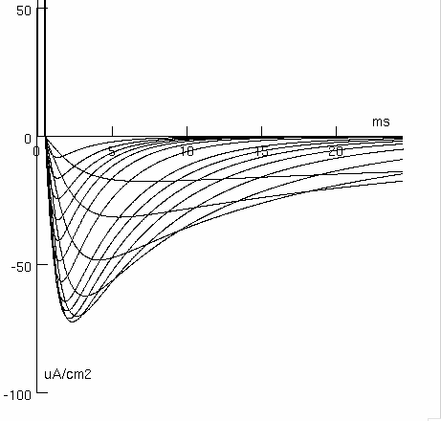

Voltage-current relationship
see Sheets and Hanck,1999, fig 1C

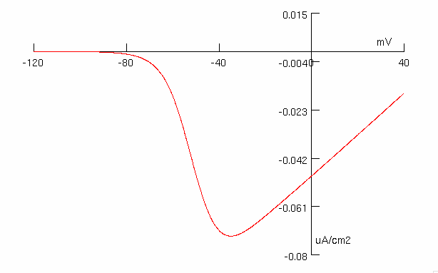

Voltage dependence of the normalised conductance
see Sheets and Hanck,1999, fig 1D

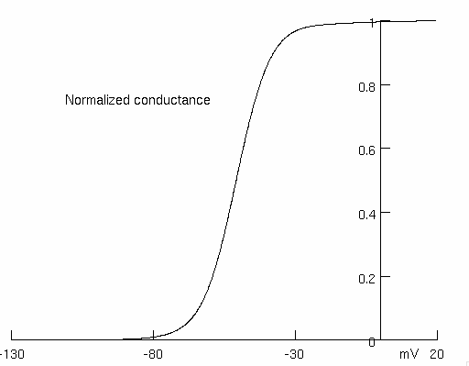

Nav1.6
Clare et al, 2000; Burbidge et al, 2002

Parameters | Experimental values | Reference | Simulation values
Temperature | 21-23°C | Burbidge et al, 2002 (pg 82) | 22°C
Sodium reversal potential | +64 mV | Burbidge et al, 2002 (pg 85) | +64 mV
TC HMA (normalized conductance) | -29.2 ± 1.8 mV | Burbidge et al, 2002 (fig 2D) | -28.9 mV
TC Slope (normalized conductance) | 6.0 ± 0.2 | Burbidge et al, 2002 (fig 2D) | -6.51
TC time of peak | < 1 ms | Burbidge et al, 2002 (page 83, fig 2A) | 0.29 ms
TC time of (full) inactivation | ~ 10 ms | Burbidge et al, 2002 (pg 83, fig 2A) | ~ 10 ms
TC start of activation | ~ -50 mV | Burbidge et al, 2002 (pg 85, fig 2A) | ~ -50 mV
TC peak of activation | -10 mV | Burbidge et al, 2002 (pg 85, fig 2A) | -14 mV
TC HMI for fast inactivation (normalized current) | -53 ± 2 mV | Burbidge et al, 2002 (fig 3B) | -48.5 mV
TC Slope for fast inactivation (normalized current) | 11.6 ± 0.6 | Burbidge et al, 2002 (fig 3B) | 16.8
TC HMI for slow inactivation (normalized current) | -71.6 ± 2 mV | Burbidge et al, 2002 (fig 3B) | -68.8 mV
TC Slope for slow inactivation (normalized current) | 6.5 ± 0.3 | Burbidge et al, 2002 (fig 3B) | 8.56
TC time constant of inactivation | 1.08 ± 0.06 ms | Burbidge et al, 2002 (fig 3C) | 1.01 ms  (tau at the peak current of -14 mV)
TC time constant of the recovery from inactivation | 12.6 ± 2 ms | Burbidge et al, 2002 (fig 3D) | 11.8 ms
Recovery curve asymptote | not available |  | 90.6 %
PC duration | > 100 ms | Burbidge et al, 2002 (fig 4A) | > 100 ms
PC proportion compared to the peak current | 26 ± 4 % | Burbidge et al, 2002 (pg 85, fig 4C) | 27.4 %

TC: transient current; HMA: half maximal activation; HMI: half maximal inactivation; PC: persistent current

Voltage-clamp: -70 mV to 70 mV in step of 10 mV
see Burbidge et al, 2002, fig 2A
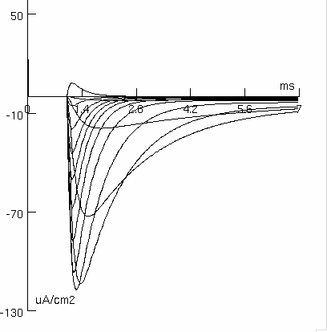

Voltage-current relationship
see Burbidge et al, 2002, fig 2C
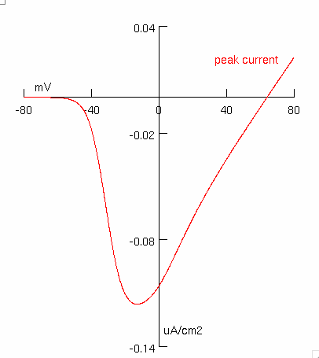

Voltage dependence of the normalised conductance
see Burbidge et al, 2002, fig 2D

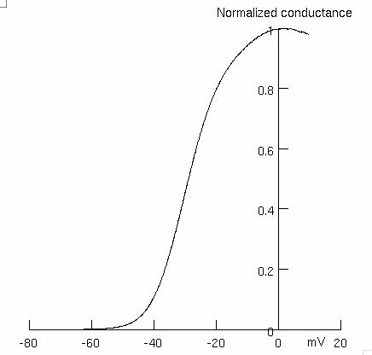

Fast inactivation protocol
see Burbidge et al, 2002, fig 3A
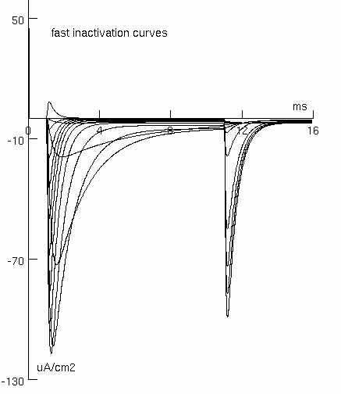

Voltage dependence of normalized current during both fast and slow inactivation
see Burbidge et al, 2002, fig 3B
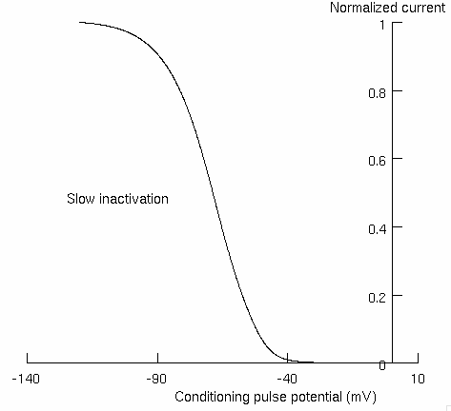
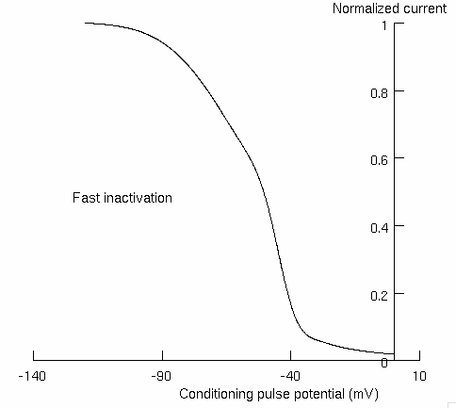

Recovery from inactivation
see Burbidge et al, 2002, fig 3D
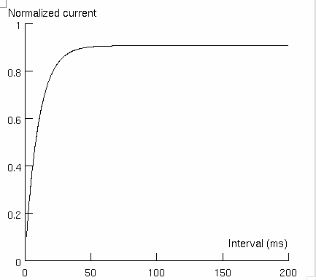

Transient and persistent currents evoked by 100-ms voltage pulses at 20-mV increments
see Burbidge et al, 2002, fig 4A
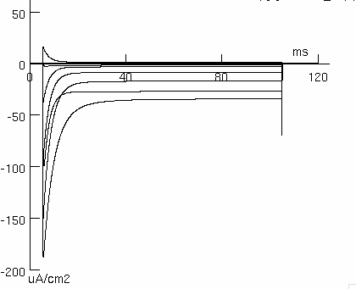

Voltage-current relationships for both transient and persistent currents
see Burbidge et al, 2002, fig 4C
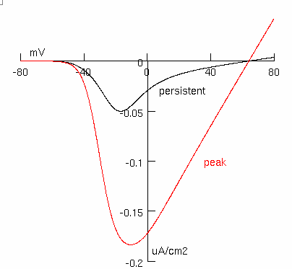

Time constant of inactivation as a function of test pulse potential
see Burbidge et al, 2002, fig 3C
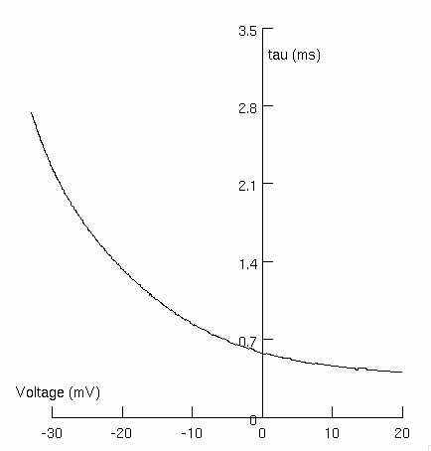

Nav1.7
Chatelier et al, 2008

Parameters | Experimental values | Reference | Simulation values
Temperature | ~ 22°C | Chatelier et al, 2008, pg 2243 | 22°C
Sodium reversal potential | ~ +40 mV | Chatelier et al, 2008, fig 2A | +40 mV
TC HMA (normalized conductance) | -36.15 ± 1.23 mV | Chatelier et al, 2008, table 1 | -36.51 mV
TC Slope (normalized conductance) | -6.66 ± 0.34 | Chatelier et al, 2008, table 1 | -6.67
TC HMI for fast inactivation (normalized current) | -93.60 ± 1.26 mV | Chatelier et al, 2008, table 1 | -93.34 mV
TC Slope for fast inactivation (normalized current) | 4.94 ± 0.24 | Chatelier et al, 2008, table 1 | 4.54
TC time constant of the recovery from inactivation | 9.54 ± 2.00 ms | Chatelier et al, 2008, table 1 | 9.82

Voltage-current relationship
see Chatelier et al, 2008, fig. 2A
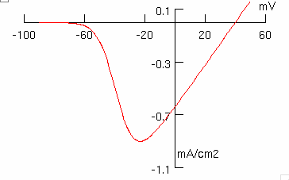

Voltage dependence of the normalised conductance
see Chatelier et al, 2008, fig. 2B
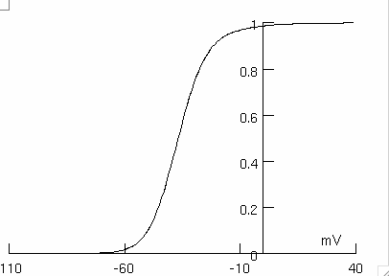

Voltage dependence of normalized current during fast inactivation
see Chatelier et al, 2008, fig. 2C
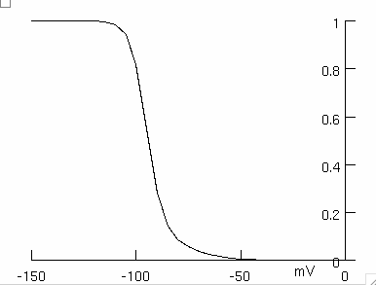

Nav1.8
Huang et al, 2013

Parameters | Experimental values | Reference | Simulation values
Temperature | ~ 22°C | Huang et al, 2013 (pg 14088) | 22°C
Sodium reversal potential | +65.3 ± 1.1 mV | Huang et al, 2013 (table 1) | +65 mV
HMA (normalized conductance) | -1.11 ± 1.6 mV | Huang et al, 2013 (table 1) | 0.98 mV
Slope (normalized conductance) | -8.77 ± 0.45 | Huang et al, 2013 (table 1) | -7.80
SS HMI for fast inactivation (normalized current) | -29.9 ± 1.2 mV | Huang et al, 2013 (table 1) | -30.8 mV
SS Slope for fast inactivation (normalized current) | 6.33 ± 0.30 | Huang et al, 2013 (table 1) | -6.4
Percentage of non-inactivating channels | 6.58 ± 0.43 % | Huang et al, 2013 (table 1) | 7.62 %
TC time constant of the recovery from inactivation (-70 mV) | ~ 4 ms | Huang et al, 2013 (fig. 3E) | 4.08 ms
TC time constant of the recovery from inactivation (-50 mV) | ~ 11 ms | Huang et al, 2013 (fig. 3D) | 10.36 ms

Voltage-clamp: -60 mV to 60 mV in step of 10 mV
see Huang et al, 2013, fig 2A
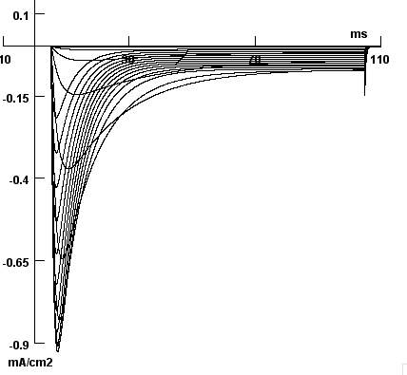

Voltage-current relationship
see Huang et al, 2013, fig 2C
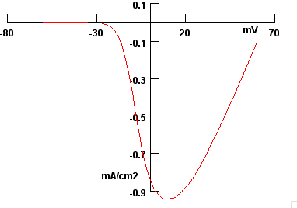

Voltage dependence of normalized conductance and normalized current during activation and inactivation, respectively
see Huang et al, 2013, fig 2D
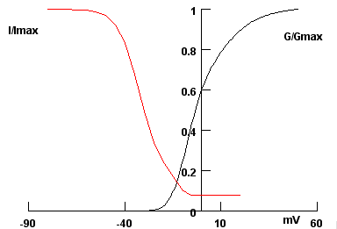

Recovery from inactivation
see Huang et al, 2013, fig 2E
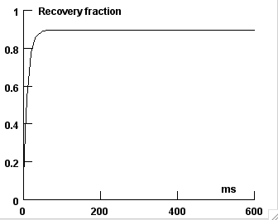

Nav1.9
Han et al, 2015
Parameters | Experimental values | Reference | Simulation values
Temperature | 22°C | Han et al, 2015 (pg 160) | 22°C
Sodium reversal potential | not available |  | 60 mV
TC HMA (normalized conductance) | -50.0 ± 1.5 mV | Han et al, 2015 (pg 162) | -50.9 mV
TC Slope (normalized conductance) | -8.4 ± 0.3 | Han et al, 2015 (pg 162) | -9.6  x₀=-45
TC HMI for fast inactivation (normalized current) | -42 ± 1.1 mV | Han et al, 2015 (pg 162) | -45.1 mV
TC Slope for fast inactivation (normalized current) | 10.3 ± 0.3 | Han et al, 2015 (pg 162) | 10.9  (x₀=-55 mV)

Current-voltage curves during voltage-clamp
see Han et al, 2015, fig 2A
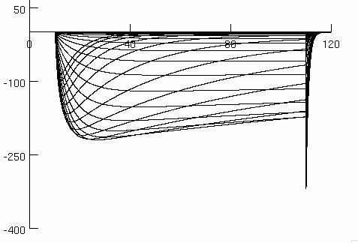

Voltage dependence of the normalised conductance
see Han et al, 2015, fig 2C

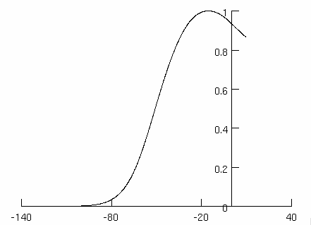

Voltage dependence of normalized current during fast inactivation
see Han et al, 2015, fig 2C

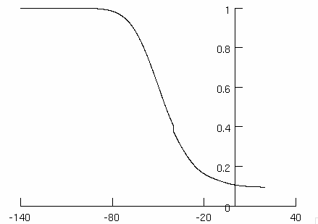

Tail current following repolarization at -70 mV
see Han et al, 2015, fig 3A inset

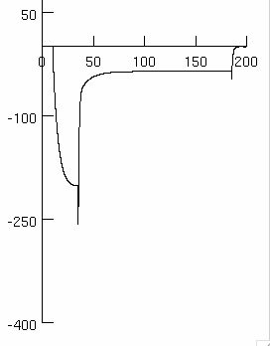

Potassium channels
mKv1.1
Hopkins et al, 1994

Parameters | Experimental values | Reference | Simulation values
Temperature | 22°C | Hopkins et al. 1994 (pg 383) | 22°C
Potassium reversal potential | not available |  | -77 mV
TC HMA (normalized conductance) | -37 ± 2 mV | Hopkins et al. 1994 (Table 1) | -37.6 mV
TC Slope (normalized conductance) | 6.1 ± 0.3 | Hopkins et al. 1994 (Table 1) | -7.1
Prepulse inactivation V^{1/2} | -49 ± 1 mV | Hopkins et al. 1994 (Table 1) | -48.8 mV
Prepulse inactivation slope | 4.0 ± 0.3 | Hopkins et al. 1994 (Table 1) | 5.6
Prepulse inactivation fraction | 0.64 ± 0.03 | Hopkins et al. 1994 (Table 1) | 0.64
Time constant of inactivation onset | 2484 ± 300 ms | Hopkins et al. 1994 (Table 1) | not performed
Time constant of the recovery from inactivation | 3304 ± 10 ms | Hopkins et al. 1994 (Table 1) | 3350 ms

Voltage dependence of the normalised conductance
see Hopkins et al, 1994, fig 1B

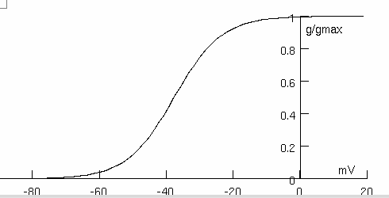

Voltage dependence of normalized current during inactivation
see Hopkins et al, 1994, fig 2B

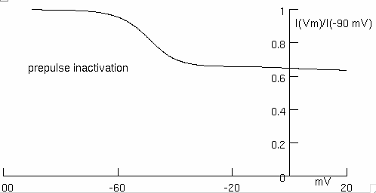

Recovery from inactivation
see Hopkins et al, 1994, fig 3B

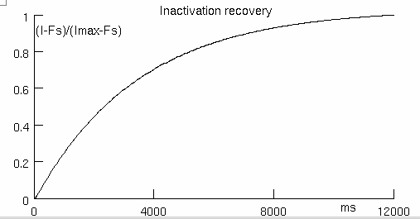

mKv1.2
Hopkins et al, 1994

Parameters | Experimental values | Reference | Simulation values
Temperature | 22°C | Hopkins et al. 1994 (pg 383) | 22°C
Potassium reversal potential | not available |  | -77 mV
TC HMA (normalized conductance) | -27 ± 1 mV | Hopkins et al. 1994 (Table 1) | -26.6 mV
TC Slope (normalized conductance) | 5.9 ± 0.2 | Hopkins et al. 1994 (Table 1) | -7.1
Prepulse inactivation V^{1/2} | -37 ± 1 mV | Hopkins et al. 1994 (Table 1) | -36.8 mV
Prepulse inactivation slope | 4.5 ± 0.2 | Hopkins et al. 1994 (Table 1) | 5.8
Prepulse inactivation fraction | 0.55 ± 0.03 | Hopkins et al. 1994 (Table 1) | 0.55
Time constant of inactivation onset | 3559 ± 272 ms  131 ± 10 ms | Hopkins et al. 1994 (Table 1) | not performed
Time constant of the recovery from inactivation | 2400 ± 272 ms  314 ± 222 ms | Hopkins et al. 1994 (Table 1) | 2250 ms

Voltage dependence of the normalised conductance
see Hopkins et al, 1994, fig 1B
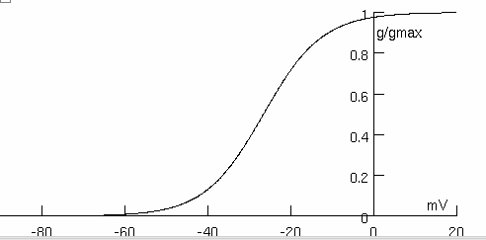

Voltage dependence of normalized current during inactivation
see Hopkins et al, 1994, fig 2B

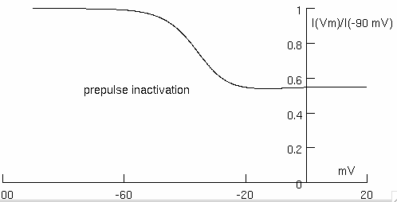

Recovery from inactivation
see Hopkins et al, 1994, fig 3B

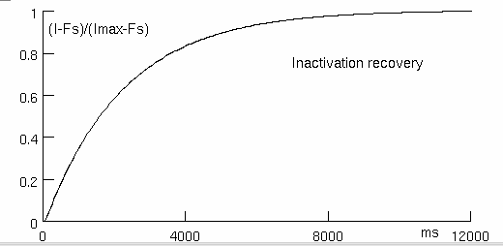

References

Arnold WD, Feldman DH, Ramirez S, He L, Kassar D, Quick A, Klassen TL, Lara M, Nguyen J, Kissel JT, Lossin C, Maselli RA. Defective fast inactivation recovery of Nav 1.4 in congenital myasthenic syndrome. Ann Neurol. 2015 May;77(5):840-50.

Burbidge SA, Daleb TJ, Powell AJ, Whitaker WRJ, Xie XM, Romanos MA, Clare JJ. Molecular cloning, distribution and functional analysis of the Nav 1.6 voltage-gated sodium channel from human brain. Molecular Brain Research 103 (2002) 80–90

Chatelier A, Dahllund L, Eriksson A, Krupp J, Chahine M. Biophysical properties of human Nav1.7 splice variante and their regulation by protein kinase A. J Neurophysiol 2008, 99: 2241-2250.

Clare JJ, Tate SN, Nobbs M, Romanos MA. Voltage-gated sodium channels as therapeutic targets. Drug Discov Today 2000 Nov 1; 5(11): 506-520.

Cusdin FS, Nietlispach D, Maman J, Dale TJ, Powell AJ, Clare JJ, Jackson AP. The sodium channel β3-subunit induces multiphasic gating in Nav1.3 and affects fast inactivation via distinct intracellular regions. J Biol Chem. 2010 Oct 22;285(43):33404-12.

Han C, Yang Y, de Greef BT, Hoeijmakers JG, Gerrits MM, Verhamme C, Qu J, Lauria G, Merkies IS, Faber CG, Dib-Hajj SD, Waxman SG. The Domain II S4-S5 Linker in Nav1.9: A Missense Mutation Enhances Activation, Impairs Fast Inactivation, and Produces Human Painful Neuropathy. Neuromolecular Med. 2015 Jun;17(2):158-69.

Hopkins WF, Allen ML, Houamed KM, Tempel BL. Properties of voltage-gated K⁺ currents expressed in Xenopus oocytes by mKv1.1, mKv1.2 and their heteromultimers as revealed by mutagenesis of the dendrotoxin-binding site in mKv1.1. Pflügers Arch (1994) 428: 382-390.

Huang J, Yang Y, Zhao P, Gerrits MM, Hoeijmakers JG, Bekelaar K, Merkies IS, Faber CG, Dib-Hajj SD, Waxman SG. Small-fiber neuropathy Nav1.8 mutation shifts activation to hyperpolarized potentials and increases excitability of dorsal root ganglion neurons. J Neurosci. 2013 Aug 28;33(35):14087-97.

Misra SN, Kahlig KM, George AL. Impaired Nav1.2 Function and reduced cell surface expression in benign familial neonatal-infantile seizures. Epilepsia 2008 Sep, 49 (9): 1535-1545.

Rhodes TH, Lossin C, Vanoye CG, Wang DW, George AL. Noninactivating voltage-gated sodium channels in severe myoclonic epilepsy of infancy. Proc Natl Acad Sci U S A. 2004 Jul 27; 101(30): 11147-52.

Sheets MF, Hanck DA. Gating of skeletal and cardiac muscle sodium channels in mammalian cells. J Physiol (1999) 514.2: 425-436.

Xie X, Dale TJ, John VH, Cater HL, Peakman TC, Clare JJ. Electrophysiological and pharmacological properties of the human brain type IIA Na+ channel expressed in a stable mammalian cell line. Pflügers Arch - Eur J Physiol (2001) 441: 425-433

Balbi P et al, Aprile 2016

Data from the 5N11S splice variant.

